Course: Project Work Phase -I
Date: 01/04/2026
Course Code: BCS685

Synopsis
PROJECT TITLE: “Swarm-based Agriculture Monitoring System (SAMS)”

Batch No: 3
Sl. No. | USN | Name | E-mail id | Contact number
01 | 1RN23CS005 | Abhijeeth K V | abhijeethkv23cs@rnsit.ac.in | 9108735868
02 | 1RN23CS018 | Akarsh Raj M H | akarshrajmhulihalli23cs@rnsit.ac.in | 7259802546
03 | 1RN23CS068 | Deepthi D R | deepthidr23cs@rnsit.ac.in | 9845433776
04 | 1RN23CS092 | Jaishnav Kalmangi | jaishnavkalmangi23cs@rnsit.ac.in | 9019558614

Internal Guide Details: | Ms. Chethana H R
Domain: | Smart Agriculture

- Introduction
Agriculture is a critical sector that requires continuous monitoring of environmental conditions such as soil moisture, temperature, and humidity to ensure optimal crop growth. Traditional farming practices often rely on manual monitoring, which can be inefficient and inaccurate. Modern IoT-based monitoring systems improve data collection but typically rely on centralized architectures, which can suffer from sensor failures and unreliable readings. Swarm intelligence, inspired by the collective behavior of natural systems such as ant colonies and bird flocks, enables distributed and collaborative decision-making among multiple nodes. This project proposes a swarm-based agriculture monitoring system where sensor nodes communicate with each other, validate data collectively, and provide intelligent insights to the analytics dashboard.

- Literature Survey
Sl. No. | Paper / Study | Work Done | Technologies / Methods Used | Limitations
1 | Swarm Intelligence: A Survey of Model Classification and Applications (2025) | Reviews swarm intelligence models and applications. | ACO, PSO, Bee Colony, multi-agent systems. | Mostly theoretical; few real deployments.
2 | Internet of Things and Smart Sensors in Agriculture: Scopes and Challenges (2023) | Explains IoT and smart sensors in precision agriculture. | IoT sensors, WSN, UAVs, AI/ML, cloud computing. | High cost, security issues, low farmer awareness.
3 | IoT-Based Smart Agriculture Monitoring System (2024) | Proposes IoT-based crop monitoring system. | ESP32, DHT11, soil sensor, WiFi, Blynk app. | Only basic monitoring and automation.
4 | MQTT Protocol for the IoT (2023) | Describes MQTT communication for IoT devices. | Publish–subscribe, MQTT broker, TCP/IP, QoS. | Centralized broker; limited security.
5 | Swarm-Based Optimization Algorithms (2023) | Introduces swarm optimization techniques. | ACO, PSO, Bee Colony, Cuckoo Search. | Parameter tuning and computational cost.
6 | Swarm Robotics and Multi-Agent Systems in Agriculture (2025) | Studies cooperative robotic systems for farming. | Multi-agent systems, robotics, AI/ML, GPS. | High cost and coordination complexity.
7 | A Comprehensive Review on IoT in Smart Agriculture (2024) | Reviews IoT applications in agriculture. | IoT sensors, wireless networks, cloud platforms. | Connectivity and infrastructure cost.
8 | Smart Sensors and Smart Data for Precision Agriculture (2024) | Discusses sensors and data use in farming. | Smart sensors, remote sensing, data analytics. | Centralized architecture, heavy data processing.
9 | AIoT for Precision Agriculture – A Review (2025) | Reviews AI and IoT integration in agriculture. | AI algorithms, IoT sensors, cloud computing. | Requires large datasets and stable networks.
10 | A Literature Review on IoT in Smart Agriculture (2025) | Surveys IoT-based agriculture systems. | IoT devices, environmental sensors, mobile apps. | Security risks and infrastructure cost.
11 | Integration of Smart Sensors and IoT in Precision Agriculture (2025) | Examines sensor-based irrigation optimization. | Soil sensors, IoT protocols, monitoring systems. | Energy and scalability issues.
12 | ML-Based Precision Agriculture with IoT Sensors – Review (2026) | Reviews ML for agricultural data analysis. | ML models, IoT sensor networks, analytics. | High computation; limited real deployment.

- Existing System and their limitations
- They use microcontrollers (ESP32/Arduino), cloud platforms, and MQTT for real-time data transmission. Swarm intelligence research shows distributed agents can collaborate without centralized control.
- However, many systems have high deployment costs, centralized architectures, or simulation-only swarm models.
- Most focus on data collection and basic automation, with limited anomaly detection and node collaboration.
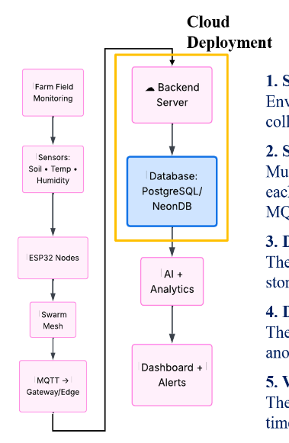
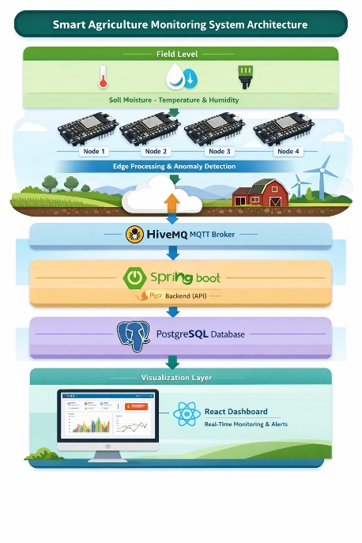
- Problem Statement of Proposed Project with Block Diagram
Agricultural monitoring often relies on manual observation or basic systems, making continuous tracking of soil moisture, temperature, and humidity difficult. This limits the ability to detect anomalies affecting crop health and irrigation. Many existing systems also use centralized architectures with limited analytics. Hence, a smart monitoring system is needed to collect real-time data, detect abnormal conditions, and support data-driven agricultural management.
Architecture
Block Diagram

- Objectives of the Project Work
- Design a distributed agricultural monitoring system with multiple sensor nodes.
- Enable swarm-based communication for collaborative and decentralized operation.
- Monitor soil moisture, temperature, and humidity in real time.
- Analyze data to detect anomalies and generate alerts.
- Develop a centralized dashboard for real-time visualization and scalable monitoring.
- Methodology
- Sensor Data Collection: Soil moisture, temperature, and humidity are collected using sensors connected to ESP32 nodes.
- Swarm Communication: Multiple nodes form a distributed network and exchange data using MQTT.
- Data Transmission: Sensor data is sent to a backend server and stored in a database.
- Data Analysis: The backend processes data to detect abnormal environmental conditions.
- Dashboard Visualization: A web dashboard shows real-time data, graphs, and alerts.
- Innovativeness & Relevance of the Project
The system combines swarm intelligence with IoT-based agriculture monitoring, enabling cooperative interaction among sensor nodes instead of relying only on centralized systems.
Key aspects:
- Swarm architecture: Nodes collaborate and validate data.
- Decentralization: Reduces single points of failure.
- Anomaly detection: Identifies abnormal conditions early.
- Fault tolerance: System works even if some nodes fail.
- Expected Outcome
- Prototype of a swarm-based agriculture monitoring system.
- Real-time environmental data collection from multiple nodes.
- Reliable MQTT communication with backend storage.
- Anomaly detection from sensor data.
- Web dashboard for live monitoring and alerts.
- Improved monitoring compared to single-node systems.
- Demonstration of practical swarm intelligence in agriculture.
Ultimately, the system aims to support smarter farming practices, reduce manual effort, enable data-driven decisions, and contribute to sustainable agriculture.

